CHAPTER 9: Sedimentary, igneous and metamorphic rocks
Worksheet 9.1

Identifying and classifying minerals
Answers

Identifying minerals  1. Two common rocks are composed of the minerals shown in the images at right. Limestone contains calcite, and sandstone contains quartz. | 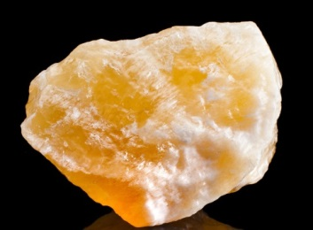 | 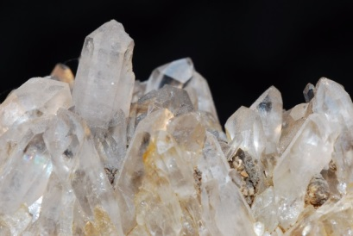
Calcite |  | Quartz

The following table provides information about the properties of these minerals.
Mineral | Colour | Streak (colour of powdered mineral) | Hardness | Lustre
Calcite | Colourless, white | White | 3 | Dull to vitreous
Quartz | Colourless, purple, red, yellow | White | 7 | Vitreous
(a) Explain how calcite crystals can be distinguished from quartz crystals.
Quartz is much harder, so a Mohs’ scale hardness test will show the difference.

(b) Pure quartz crystals are colourless. Explain the large variation in colour indicated in the table.
Coloured impurities can lead to significant colour changes.

Creating a classification key
2. Use the following table to create a written classification key for these minerals.
Mineral | Colour | Streak | Hardness | Lustre
Chalcopyrite | Yellow | Green, black | 3.5–4 | Metallic
Chlorite | Grey | White, green | 2.2–5 | Pearly
Galena | Grey | Grey | 2.5 | Metallic
Haematite | Grey | Red, brown | 5–6 | Metallic
Magnetite | Black | Black | 5.5–6.5 | Metallic
Pyrite | Yellow | Green | 6–6.5 | Metallic

Calcite photo: madllen / 123RF.com
Quartz photo: thomaseder / 123RF.com

Key:
1A. Mineral is grey go to 2
1B. Mineral is not grey go to 4
2A. Streak is grey galena
2B. Streak is not grey go to 3
3A. Mineral has a metallic lustre haematite
3B. Mineral has a pearly lustre chlorite
4A. Mineral has a hardness less than 5 chalcopyrite
4B. Mineral has a hardness of 5 or greater go to 5
5A. Mineral is black magnetite
5B. Mineral is yellow pyrite

